Front End Tools:

Essential/expected features:
- Integrated Development Environment (IDE)
  - Designing (preferred)
  - Programming
  - Debugging
  - Testing
  - Global Project Management features for global multi teams
- Development Framework Integration

For E-Commerce
- Three tier hierarchy:
  - Category/Subcategory/Product
- User friendly Clear navigation
- Easy integration of ecommerce systems &Easy to integrate into existing site
- Ability to have multiple navigation based on Manufacturers, Categories & Products
- Home page features
  - Selection of Products based on categories Category selection
  - Featured Items display Display of featured items
  - Display of Sale Items Display of Sale items
  - Manufacturer Listing Display of Manufacturers
  - Content Management System to add content Content Managed Pages
- Shopping Cart features
  - Quantity update
  - Indication of savings for sale items
  - Shipping method selection
  - Redeeming coupons
- Checkout features
  - Ability to transfer shipping field data into billing fields
  - Express checkout for returning customers
  - Checkout indicators - Progress indicators at bottom of each page throughout checkout
- Order review page features include:
  - Easy to edit information
    - Easy to read display of shipping/billing/payment information with ability to edit this information.
  - Easy listing on order review page
    - Itemized list of products along with tax, shipping and total
  - Ability to add comments to order
    - Text area for delivery instructions and other customer comments
  - Assignment of new password to customers
    - Input of password for new customers

Sales Force Automation Architecture

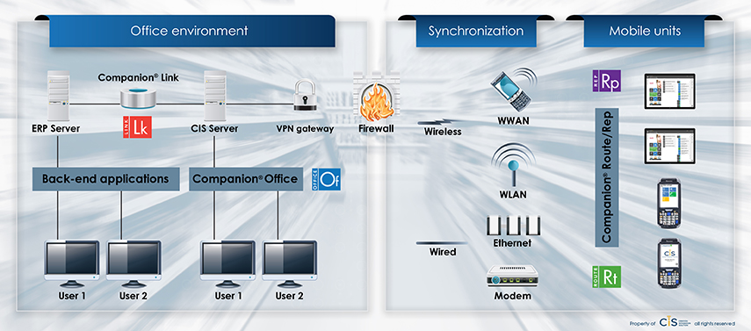

Above architecture focuses on

Interoperability, scalability and management of tools and software

Each one of the above supported by 3/n-tier architecture capabilities.

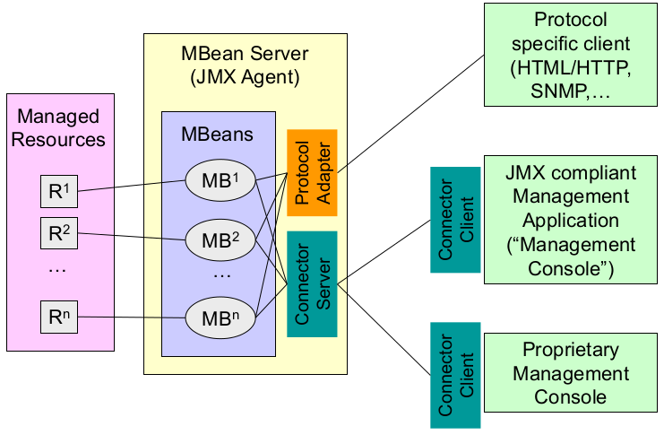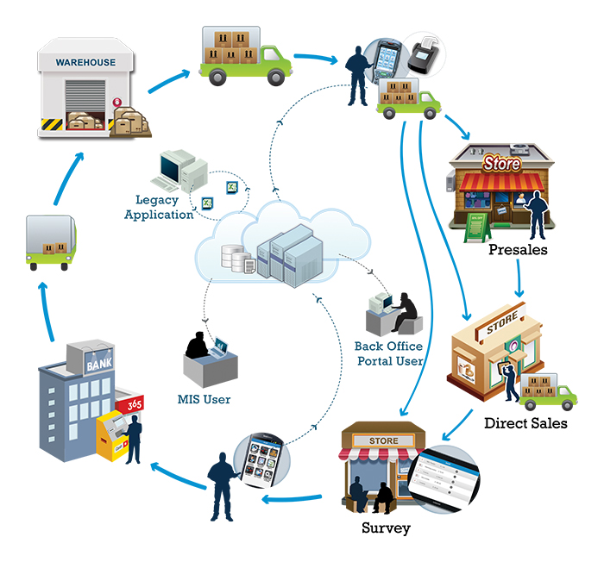

Architecture of an n-tier application for sales persons in a company and sales operations

Accounting software architecture using Sharepoint

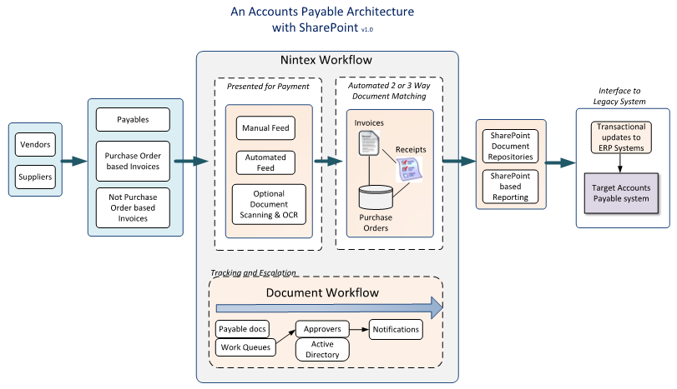

Courseware

